## HOTEL GJCL – Online booking website

## Priorities List

#### Functional Features:

1. **Essential: (necessary for system to be useful)**

Initially home page is same for everyone, who visit the site.

* 1. **Management :** 
     1. Should login to the site, to get the extra access to the website
     2. Create/update room description, price, no of beds, no of rooms for each type
     3. Can view booking summary, customers lists and payment summary
  2. **Customer:**
     1. Customer should be able to find the room/rooms based on room type, no of beds, check-in and check-out dates.
     2. First time customers should register online through the website, for booking a room. This will makes them the next booking easier.
     3. At the time of registration, customer should choose a unique login ID, password and provide their address details. Successful registration will send confirmation email along with login information.
     4. After the registration every time customer must login to the website to book room/rooms.
     5. Customer should be able book room/rooms based on the room availability on provided dates.
     6. Upon successful booking, customer will receive an email with booking id, room type, check-in, check-out dates and payment details.
     7. Provide a secure payment gateway for payments during online booking.

1. **Important: (can be added later)**
   1. Add a feature to write, store and view reviews from various customer.
   2. Add a feature to provide discounts to customer
   3. Add a feature to classify customer based on the no of booking and payments made.
2. **Extras: (nice to have)**
   1. Able to generate revenue reports on monthly basis.
   2. Send greeting to customer on special occasions.

#### Non-Functional Features:

* User friendly, customer should get necessary information easily while booking rooms.
* Need to use Oracle for database design
* Use python for Linux support

## ER Diagram

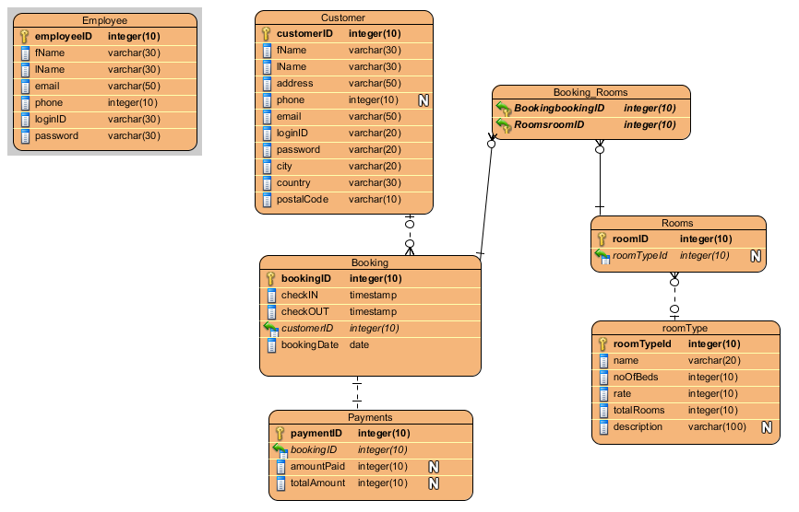

## Site Diagram:

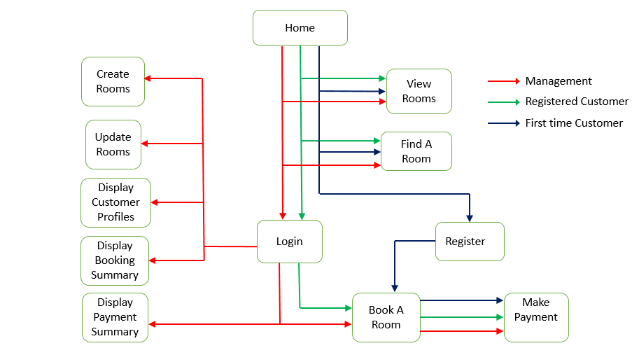

## Use-Case Diagram:

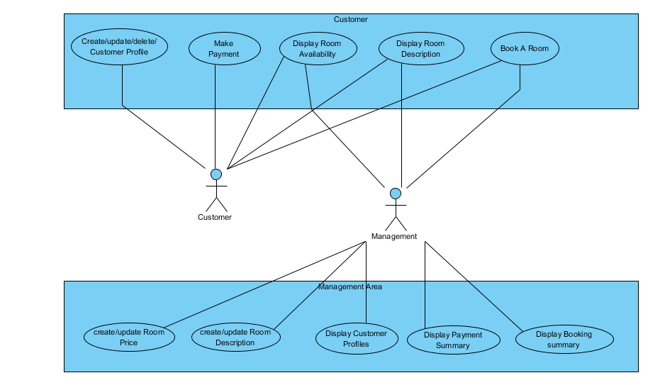

## CRUD Analysis:

|  |  |  |  |
| --- | --- | --- | --- |
| **Use Case** | **Entity** | **CRUD** | **Actors** |
| Create room price | Room | Create | Management |
| Update room price | Room | update | Management |
| Create room description | Room | Create | Management |
| Edit room description | Room | update | Management |
| Display room description | Room | Read | Management/ Customer |
| View Customer Profiles | Customer Profiles | Read | Management/  Customer |
| Create Customer Profiles | Customer Profiles | Create | Customer |
| Edit Customer Profiles | Customer Profiles | update | Customer |
| Make Payment | Payment | Create | Customer |
| Display room availability | Room | Read | Management/  Customer |
| Book a room | Booking Profiles | Create | Management/  Customer |
| Display payment summary | Payment | Read | Management |
| Display booking summary | Booking Profiles | Read | Management |